INDIANA UNIVERSITY BLOOMINGTON

S660: Sociology of Education

Jennifer Lee

Spring 2015

Research Proposal

Effects of partnership homogamy on relationship quality and stability _________________________________________________________________________________________________________________________

Isabelle Fischer

05/07/2015

**Contact:**

3200 E John Hinkle Place

Bloomington, IN 47408

🕿 812-527-7482

🖃 fischeri@umail.iu.edu

# 1 Introduction

*“Choose your life's mate carefully. From this one decision will come 90 percent of all your happiness or misery.”*

― H. Jackson Brown Jr., The Complete Life's Little Instruction Book

This quotation of an American bestselling author illustrates the critical importance of mate selection. However, bookstores and newspaper kiosks are not the only places where one can find numerous musings on the best approach for the search for “the one.” Researchers of a variety of scientific disciplines have dealt with this topic for many years. Their aims are to decipher the factors which influence relationship success and to uncover the underlying mechanisms concerning mate selection.

The lion’s share of the studies that have been carried out suggests that homogamy theories are most suitable to explain these mechanisms. According to these theories, people tend to start a relationship with someone who is similar to them. The characteristics that sociologists identified as important include: education, religion, social status and ethnicity (Kalmijn 1998; Esping-Andersen 2009).

Psychologists, however, focus on the role of preferences and personality traits (Buss and Barnes 1986). Eysenck and Wakefield (1981), for example, studied engaged couples in terms of personality traits and marital satisfaction. Their results suggest that similar couples lead a more successful marriage.

The number of studies that attempt to combine aspects of both approaches is limited and often education is used as a proxy for preferences and attitudes instead of measuring these aspects separately.

If one takes a closer look at the methodological studies on partnership success and relationship quality, it is apparent that their results are highly contradictory (Hahlweg 1991). There is no agreement as to which factors most strongly influence a relationship or whether the identified factors have a positive or negative impact on the relationship. This is one of the reasons why, despite the impressive number of years of research, this subject has lost neither its actuality nor its scientific relevance. Furthermore, its significance lies in the fact that people spend a considerable part of their lives in close social bonds. Considering this, it is not surprising that few events in life have such negative consequences as a breakup or a divorce.

Thus, it is essential to prevent these incidents. In order to do so, one has to obtain knowledge of the factors that influence the quality of a relationship. Is the aforementioned principle of homogamy crucial only when it comes to selecting a partner? Or could it also affect relationship quality? Put briefly, are relationships based on the principle of homogamy of a higher quality than heterogamous ones?

These questions shall be addressed in the paper at hand. Though there are many dimensions of homogamy, I am especially interested in the effect of educational homogamy, or, more precisely, I want to examine if I as well find the positive influence of education on relationship stability and quality so often reported by several scholars (e.g. Tynes 1990; Garfinkel, Glei & McLanahan 2002; Goldstein & Harknett 2006) and if so, I would like to explore if this effect still holds after taking into account the important concepts of homogamous norms, values and preferences, which have yet to be investigated. As mentioned above, scholars usually use education as a proxy for these constructs. Although I am convinced that education plays a crucial role in the mate selection process, e.g. due to its importance as an indicator for status or the structuring effects of the educational system, I believe that the use of education as a proxy for norms and values is not a suitable approach. It is true that the extent of education a person achieved might influence the norms, values and preferences of said person, but educational attainment is only one of many factors that are involved. Socialization, which comprises a number of elements besides education, has a tremendous impact on the formation and internalization of these constructs. Therefore, I expect that the effect of homogamous norms and values differs from the effect of educational homogamy and that the effect of educational homogamy can still be found after homogamous norms and values have been taken into account.

By combining different types of homogamy studied by various scholarly fields – an enterprise long overdue – I hope to provide a starting point for a new way of analysis and to contribute to a more insightful, deeper understanding of the underlying mechanisms of the mate selection process.

# 2 Related research

## 2.1 A Sociological Perspective of Homogamy

Sociologists usually define the concept of homogamy as the similarity of partners in a relationship, for example, in terms of age, religion, race, or social origin. However, the partners’ level of education is by far the most studied characteristic and an essential criterion. On the one hand, this is due to the fact that education can be seen as a crucial variable for mate selection, since it reflects, at least to some degree, the cultural resources that affect individual preferences (Blossfeld and Timm 2003a). On the other hand, the degree of educational homogamy is an informative indicator for the rigidity of social boundaries, which describes the changes in the structure of households and families (Schwartz and Mare 2005). Additionally, due to its structuring effects, the educational system became an important marriage market over time (ibid.). The macro-sociological approach of examining (educational) homogamy prioritizes these effects. According to Blossfeld and Timm (2003a), the less able individuals and those from underprivileged families leave the educational system earlier than their counterparts who are better off. This selection process leads, in turn, to an increasing number of homogeneous groups within the educational system.

Plainly, they adopt one of Blau’s (1994) basic ideas – that structural homogenization has considerable consequences for the composition of social networks. In his view, the probability of forming meaningful friendships and relationships primarily depends on possibilities of contact. Thus, true to the phrase “who does not meet, does not mate,” a relationship with a similar partner becomes more likely due to the mere fact that similar individuals stay together in the educational system for a longer period of time. Simultaneously, the probability of building a bond with persons with other levels of education decreases significantly.

Other social researchers, too, see the basis for strong ties in socio-structural similarities (cf. Feld 1981; Fischer et al. 1977). Esping-Andersen (2009), however, is one of the few scholars who further clarifies this approach. He underlines the importance of shared values and preferences, which, according to him, are crucial for a successful relationship. He argues that partners with comparable social backgrounds and thus similar levels of education should have identical tastes, values and norms. Consequently, educationally homogamous couples should have identical preferences.

The idea of combining norms and relationships in a theoretical approach is not new. As early as 1978, McKenry et al. concluded that in order to understand human social behavior it is essential to take a close look at the individuals’ conceptions of values. They are convinced that the value systems of the two partners in a dyadic relationship interact continuously, thereby developing values regarding family and gender roles. The failure of this process leads to profound differences in values between the two parties, which contributes to the partnership’s instability.

Barelds and Barelds-Dijkstra (2007) emphasize the relevance of homogamy as well. They point out that it is usually extremely encouraging and reassuring to meet someone who is very similar to us. This is because these people validate our value system, our opinions and attitudes and our lifestyle. Furthermore, individuals, who are similar to us, seem more likeable. One attributes favorable values and attitudes to them, since everyone assumes that his or her own values and attitudes are the “right” ones.

## 2.2 Definitions of the quality of partnerships

## Social-psychological research not only analyzes the choice of partners, but is often interested in two other major constructs that are closely connected with relationships or marriages: the stability and quality of partnerships. The problem is that there is no uniform definition for any of the two constructs. Therefore, one can find a variety of methods of operationalization in the existing literature. According to Dinkel (2006), who deals with the different approaches on this subject in detail, one can distinguish three closely interwoven aspects of quality definitions. First, he mentions objectifiable, structural characteristics of a partnership, which he sums up with the term “relationship quality”. Second, he talks about the subjective evaluation of the relationship, which is equated with relationship satisfaction. The third characteristic is the continuance of the relationship, which he labels “relationship stability”.

The assumption that relationship quality is objectively measurable is widespread among social scientists. The most famous proponent of this view is probably Graham Spanier, who designed the Dyadic Adjustment Scale (DAS). The DAS is based on the assumption that relationship quality – also known as dyadic adjustment – can be described upon its position on a continuum that ranges from good to bad. This position depends on several factors: 1) disagreements, 2) interpersonal tensions and individual anxiety, 3) satisfaction with the couple’s relationship, 4) cohesion and 5) consensus on important issues affecting the relationship (Spanier 1976). Although Spanier’s musings were often criticized in the past, be it due to the dimensionality of the constructs, Spanier’s inconsistent argumentation (Dinkel 2006) or the way the components are combined (ibid.), the DAS is still one of the most commonly used instruments for examining partnership quality.

Another aspect, with which one can draw conclusions about the quality of a partnership, is relationship stability. Since the term is interpreted very differently in the literature, it also proves to be problematic in terms of a precise definition. The classifications range from couples who seriously consider separation to already separated or divorced couples (Dinkel 2006).

The last point worthy of discussion is the correlation between relationship quality and relationship stability. It seems plausible that successful relationships should also be stable, while it might be expected that unhappy relationships will be terminated. In contrast, Lewis and Spanier (1979) emphasize that the quality and stability of a partnership are independent of each other and thus should be considered separately. They note that there are both durable, yet unhappy relationships and successful, yet unstable relationships. They do not provide an explicit explanation of this phenomenon. However, normative and cultural circumstances could play a role. If the couples are embedded in a context that leads to an internalization of values ​​and explicit standards of conduct regarding the indissolubility of relationships, their partnerships will probably be dissolved less often (Hunkler and Kneip 2008).

To fully take all these factors suitably into account, it is necessary to divide the feature “relationship stability” into two parts. On the one hand, there is the subjective relationship stability, which results from both partners’ personal assessment of the durability of the partnership, and on the other hand, there is the objective relationship stability, which contains information about the formal status and the duration of the relationship (ibid.).

Relationship satisfaction, a purely subjective criterion of quality measurement that is often praised for its conceptual simplicity and clear interpretability (Dinkel 2006), will not be used in the proposal at hand. The reason for this is the well-known and widespread problem that often occurs in regard to satisfaction judgments: the general tendency of respondents to report a very high level of satisfaction.

## 2.3 Relationship quality and stability: Family economists’ approach

Becker et al.’s (1977) approach called “family economics” belongs to the group of rational choice approaches and states that individuals are primarily concerned with the satisfaction of their needs and hence act with the aim of maximizing individual benefit. According to the authors, this principle can also be applied to relationships. Thus, the dissolution of a partnership is the result of a comparison between the cost/benefit ratio regarding the current relationship and its best alternative. If the comparison leads to results in favor of the alternative, a rational individual will end the relationship.

According to Hunkler and Kneip (2008), who share this family economical perspective, small benefits in a relationship (in other words, a low relationship quality) are mainly due to a lack of investment in relationship-specific capital. However, a second evaluation of the costs and benefits based on new information can have a negative impact on the perceived outcome as well (ibid.). Furthermore, it must be noted that the assessment of the benefits of a relationship with the current partner has been affected by the information asymmetry on the marriage market (Becker et al 1977). That is, it is possible that the assessment undertaken prior to the beginning of the relationship is quite flawed and the expected benefit might differ a lot from the actual one.

## 2.4 Linking homogamy, quality and stability

For the purpose of this study, it seems beneficial to take a closer look at the links between homogamy and both relationship quality and stability and to summarize the presented arguments. The majority of previous research, which studies at least some aspects of this issue, finds that homogamy is advantageous and favorable. As early as 1976, Hill, Rubin, and Peplau discovered that similarities between dating couples can predict whether the couple will still be together two years later. Contemporary studies, too, suggest the existence of such a correlation. Garfinkel, Glei and McLanahan (2002), for example, claim that educational heterogamy is connected to instability of both marital and non-marital relationships and Goldstein and Harknett (2006) state that married couples with the same race or ethnicity were more likely to stay married after the birth of their first child than couples who crossed race/ethnic lines. Brines and Joyner (1999) focus on the part of household income that is provided by each partner. They find that “partners whose employment and earnings are increasingly similar face sharply reduced risks of breaking up” (p.333). Interestingly, this effect is asymmetric: Heterogamy causes much more disruption when the woman earns more than her partner. Considering that Bitter (1986) reports similar findings for the effect of educational homogamy (which only causes instability when the wife is the one with a higher degree of educational attainment), this indicates that traditional aspects might play an important role as well. This is all the more reason for including norms into the analyses and further justifies my approach.

Morry (2005) attributes the positive impact of homogamy to a higher relationship quality. She argues that similarities are important to satisfaction because they facilitate partnerships and reduce the risk of conflict. Some years earlier, Tynes (1990) suggested a similar connection between homogamy and relationship quality, and stated that “social status characteristics are prominent factors both in selecting a mate and in the ultimate satisfaction with marriage, with some research findings indicating that homogamous unions result in greater satisfaction” (p.153-54).

The effect of relationship quality on its stability seems to be clear as well. Like Amato (2007) remarks, previous research shows exceptionally high correlations in marital happiness and other factors of relationship quality in stable marriages.[1] For example, according to Karney & Bradbury (1995), a couples’ perception of the quality of their relationship contributes to the stability of their partnership, with a high quality leading to a more stable relationship. Wiik et al. (2009) also assume an association between relationship quality and dissolution risks.

However, as mentioned in the previous sections, some scholars disagree with the notion that all stable relationships are happy and that all unhappy relationships are instable. To take these objections into account, I consider different aspects of stability: a subjective and an objective part. To the best of my knowledge, my study is the first to examine these two aspects of stability. Therefore, this part of my analyses is merely explorative and descriptive. I hope to shed some light on this topic and to uncover whether such a distinction can provide a more detailed insight.

## 2.5 Hypotheses

The theoretical approaches presented in this paper allow for the derivation of various assumptions. Looking at Barelds and Barelds-Dijkstra’s (2007) reflections on the relevance of homogamy, the first hypothesis can be deduced.

1. *Any form of homogamy (be it educational or the homogamy of norms) should have a positive impact on relationship quality,*

since the partners get the impression that the other one understands them. Additionally, as mentioned above, the authors claim that people tend to evaluate similar others more positively, which should increase the relationship’s appeal.

The rationale of the family economical perspective is the satisfaction of needs through maximizing benefits and minimizing costs. This aspect suggests that

1. *increasing relationship quality leads to more relationship stability (objective as well as subjective)*

because remaining in a high-quality relationship results in large benefits and the probability of finding a better alternative decreases considerably. In addition, the costs that arise from the search for an alternative partner would not be justified in a high-quality relationship; it is more economical to maintain the current relationship status. Following this logic, it can be assumed that

1. *homogamy has a positive impact on both forms of relationship stability*.

Taking a closer look at the different types of homogamy and Esping-Andersen’s (2009) theoretical approach concerning educational homogamy in particular, a fourth hypothesis can be derived, which states that

1. *as a result of its underlying structural conditions, educational homogamy leads to a homogamy of norms.*

This follows from the idea that, due to the strong structural effects of the educational system, people with the same level of education should also have a similar social background.

If these four hypotheses hold true, one would expect that

1. *the effect of educational homogamy on relationship quality and stability vanishes as soon as homogamy of norms is added to the model.*

I am especially interested in the last hypothesis, because I do not believe that the effect of educational homogamy can be reduced to a homogamy of norms. If the last hypothesis has to be rejected, I can conclude that there are other processes related to educational homogamy that affect relationship quality and stability and that the use of educational homogamy as a proxy for norms and values is not a suitable approach.

# 3 Procedures and study design

## 3.1 Data set

The necessity of working with well-founded and sound data on relationships calls for a complex study design. For the analyses, I will use part of the data from the German multidisciplinary longitudinal study “pairfam” (Panel Analysis of Intimate Relationships and Family Dynamics), which is made available to every student by the University of Mannheim.[2]

The study began in 2008 and is supposed to continue for 14 years, until 2022. It originally comprised a sample of 12,402 respondents (also called “anchor person”). This sample was selected from the population (all German citizens with the birth cohorts 1991-93, 1981-83 and 1971-73) by randomly drawing 42,000 addresses from the population registers of 343 randomly chosen communities. 4,334 interviews could be obtained for the youngest cohort. For the middle cohort 4,016 interviews were realized, and for the oldest cohort 4,052. Overall, the response rate for the first wave amounted to 36.9 percent. There was a significant difference between cohorts: 49 percent for the youngest, 33 percent for the middle group, and 32 percent for the oldest. In Germany, response rates below 40 percent are prevalent. Thus, pairfam is not out of the ordinary, the only peculiarity might be the comparatively high response rate for the youngest cohort.

The implemented multi-actor approach with annually repeated interviews of the anchors and their partners, children, and parents is a vital element of the data set’s design. The fact that the anchors’ partners participated as well makes pairfam especially suitable for the study proposed in the present paper.

Since pairfam’s questionnaire does not consist of the same modules every year, I have to create my own data set which includes some variables from the first wave. In addition, I will match the information of the partners to those of the corresponding anchor persons and then exclude all anchor persons who are single.

All couples with inconsistent values with respect to gender and year of birth of the partners will be removed from the data set. Moreover, I am only interested in couples who are living together and in which both partners are at least 18 years old because I assume that these relationships are “serious.”

Additionally, I will not take into account couples in which one of the partners (or both) has missing values in regard to the relevant variables.

After all these adjustments, 1,448 couples will remain in the data set.

## 3.2 Operationalization and description of methods

### a) Independent variables

**Educational homogamy.** In order to measure educational homogamy, I plan to create a new variable for each of the partners which describes their highest level of education attained by using one of the following categories: low, medium or high level of education. The two original variables are sdp7 (*I would now like to ask you for some information about your partner. What is the highest level of school education [name partner (sd4n)] attained?*) and sd27 (*What is the highest level of school education you attained?*) I will define low level of education (1) as *Left school without a certificate* and *Secondary general school leaving certificate*; medium level of education (2) will contain *Intermediate school leaving certificate*, *Certificate from lower secondary school* and *Certificate from medium-level secondary school*; and high level of education (3) will include *Entrance qualification for universities of applied sciences* and *General or subject-specific university entrance qualification*.[3] People who answered *Other school leaving certificate*, *Don’t know* or refused to answer will be excluded from the analyses. Couples with a similar level of education will be considered educationally homogamous. This can be measured using a difference variable. If the difference between the values of the two created variables equals zero, the couple is educationally homogamous.

**Homogamy of norms.** There are six important variables in the data set that deal with norms. The participants were asked to indicate their level of agreement to six statements[4] using a Likert scale which ranges from 1, *Disagree completely*, to 5, *Agree completely*. Both anchor and partner had to answer these questions.

It is important to note that not all of these statements are aligned in the same “direction.” For example, large values regarding the statement *You should get married if you permanently live with your partner* (val1i2) demonstrate a very conservative attitude, whereas people who chose *Strongly agree* regarding the statement *Men should participate in housework to the same extent as women* (val1i4) seem to be more modern. Hence, it is crucial that I recode the variables. I decided that the following should be the case: the larger the value, the higher the level of conservatism.

Furthermore, I plan on conducting a factor analysis in order to uncover potential correlations between the six statements. It is possible that some of these statements measure attitudes concerning marriage while others evaluate cultural patterns of conduct as well as stereotyped roles.

Following this, I want to create additive indices for anchor and partner. Depending on the results of the factor analysis, I am also going to differentiate between groups of norms. The indices will be dichotomized as follows: 0 = progressive and 1 = conservative. Once again, I am going to use difference variables to determine whether the couple has homogamous norms. If the difference between the values of the two corresponding variables equals zero, the couple is considered homogamous.

## b) Dependent variables

**Relationship quality.** I plan to operationalize this dependent variable with several variables. Pairfam collected data on indicators for relationship quality through dyadic coping. That means, the researchers asked both anchor and partner for a self-assessment and an assessment of the significant other, resulting in a total of 12 variables.[5] The indicators are the level of *Understanding* within the relationship, *Help with problems* and the extent to which anchor and corresponding partner *listen to each other*. For each indicator and person, I am going to combine self-assessment and the appropriate peer assessment which leads to six additive indices.[6] In a next step, all of these indices and the satisfaction variable are merged into another index which reflects the overall quality of the relationship.

**Relationship stability.** I decided to measure two different kinds of stability: the objective and the subjective stability. While the objective relationship stability is measured with a single item, viz. the duration of the relationship in years[7], the subjective aspect consists of three questions that were answered by both anchor person and partner. The respondents had to indicate whether they thought that their partnership was in trouble (pa26), whether they seriously considered a separation (pa27) and whether they seriously proposed a separation (pa28). For all of these questions the respondents were asked to think of the previous year.

Once more, I will use these variables to create an additive index, containing the information from both anchor and partner. The resulting variable will be defined as 1, *unstable*, 2, *moderately stable*, and 3, *stable*.

I do not intend to combine subjective and objective relationship stability; rather, I am interested in whether the various types of homogamy affect the two types of stability in a different way.

### c) Control variables

First of all,I am going to control for religiousness of each of the partners because it could influence the objective relationship stability. Religiousness is measured by the frequency of participating in religious ceremonies[8] (sd31). Since there is no variable for the number of children that live with the couple, I have to create it by combining information of the variables sd14kx_ (*Please tell me the name and sex of your [x-th] child*) and sd20kx (*Does [name of the s-th child (sd14kxn)] currently live with you?*). This approach might seem complicated but I am of the opinion that the number of children can greatly influence the quality and stability of a relationship.

**Description of methods.** I want to use a variety of methods to test the validity of the hypotheses. Firstly, I am going to run a Chi-square test and its associated Cramér's V test to uncover whether educational homogomay actually correlates with the homogamy of norms. If this is not the case, the variable measuring the homogamy of norms will be included in the subsequent linear regressions, which are used to determine the influence of the various independent variables on the three dependent variables. Each of the regression tables will include two nested models: the first one will only consist of educational homogamy and the control variables. In the second one, I will add the variable that measures the homogamy of norms.

The second hypothesis is tested using Spearman's ρ and crosstabs. In this way, it can be determined whether there is a significant relationship between the two forms of relationship

stability and relationship quality. Whether the remaining hypotheses hold true can be examined by studying the regression tables mentioned above.

# 4 Limitations

It is quite obvious that it is essential to conduct further research concerning this issue. These additional studies should include, inter alia, age effects. Due to the young age of the respondents, it was not possible to investigate these effects in the present work. In addition, an analysis of other types of homogamy would be extremely interesting. For example, Zhang et al. (2012) show that age gaps within a partnership correlate with divorce rates. The bigger the age gap, the more likely that the couple will divorce. Unfortunately, the sample used for the present paper didn’t provide a sufficiently large number of cases to integrate this factor into the analyses.

For the same reason, it was not possible to distinguish between immigrants and Germans; although a comparison of Christian norms, which prevail in Germany, and Muslim values, for example, would definitely be of interest.

Social origin can be considered another interesting factor which might influence both homogamy and partnership quality. It is possible that there are clearly defined individual preferences which determine the choice of partners within given social circles.

In general, it must be noted that a longitudinal analysis might produce more informative results because the use of cross-sectional designs involves the problem of ex post facto interpretation. Only the stock of relationships at a given point in time can be examined. The dynamics of partner decisions are not taken into account. Thus, starting from existing matches and trying to give an explanation of patterns of assortative mating through the partners’ individual characteristics might not be the best approach. Evidently, there are several methodological problems, e.g. the exclusion of all those persons who are single at the time of the study’s conduction and the complete disregard of the active interplay of opportunity structures in particular phases in the life course.

Furthermore, the use of life-history data and longitudinal statistical models allows the researcher to examine if the respondents chose their partners based on specific characteristics or if these partners changed during the course of the relationship. For example, do both partners have a university degree because they wanted to be with someone with a similar educational background or did one of them attain the degree during the relationship because he or she felt pressured to do so?

In sum, there are various possibilities for future research to shed more light on the mechanisms underlying mate selection and assortative mating. But all in all, this issue has proven to be very captivating and will certainly inspire numerous informative studies.

# Bibliography

|  |
| --- |
| Amato, P. R. (2007). Transformative processes in marriage: Some thoughts from a sociologist. *Journal of Marriage and Family*, *69*(2), 305-309. |

Barelds, D. P. H. & Barelds-Dijkstra, P. (2007). Love at first sight or friends first? Ties

among partner personality trait similarity, relationship onset, relationship quality, and

love. *Journal of Social and Personal Relationships, 24*(4), 479–496.

Becker, G.S., Landes, E. M., & Michael, R.T. (1977). An economic analysis of marital instability. *Journal of Political Economy*, *85*(6), 1141-1187.

Bitter, R. G. (1986). Late marriage and marital instability: The effects of heterogeneity and inflexibility. *Journal of Marriage and the Family*, 631-640.

Blau, P. M. (1994). *Structural contexts of opportunities.* Chicago and London: University of Chicago Press.

Blossfeld, H.-P., & Timm, A. (2003a). Educational systems as marriage markets in

modern societies: A conceptual framework. In H.-P. Blossfeld & A. Timm (ed.), *Who*

*marries whom? Educational systems as marriage markets in modern societies* (pp. 1–18). Dordrecht: Kluwer Academic Publishers.

Brines, J., & Joyner, K. (1999). The ties that bind: Principles of cohesion in cohabitation and

marriage. *American Sociological Review*, *64*, 333 – 355.

Buss, D. M. & Barnes, M. (1986). Preferences in human mate selection. Journal of Personality and Social Psychology, 50, 559–570.

Dinkel, A. (2006). *Der Einfluss von Bindungsstil und dyadischem Coping auf die partnerschaftliche Beziehungsqualität: Eine Analyse moderierter Mediationseffekte.*

Accessed via http://www.qucosa.de/fileadmin/data/qucosa/documents/1787/

1165408270585-0762.pdf

Esping-Andersen, G. (2009). *Incomplete Revolution: Adapting Welfare States to Women's New Roles.* Cambridge: Polity Press.

Eysenck, H. J., & Wakefield, J. A. (1981). Psychological factors as predictors of marital satisfaction. Advances in Behavior Research & Therapy, 3, 151–192.

Feld, S. L. (1981). The focused organization of social ties. *American Journal of Sociology*, *86*(5), 1015–1035.

Fischer, C. S., Jackson, R. M.., Stueve, C. A., Gerson, K. & Jones, L. M. (1977). *Networks and Places: Social Relations in the Urban Setting*. New York: Free Press.

Garfinkel, I., Glei, D., & McLanahan, S. S. (2002). Assortative mating among unmarried parents: Implications for ability to pay child support. *Journal of Population Economics*, *15*(3), 417-432.

Goldstein, J. R., & Harknett, K. (2006). Parenting across racial and class lines: Who are married, cohabiting, dating or no longer romantically involved? *Social Forces*, *85*, 121 – 143.

Hahlweg, K. (1991). Störung und Auflösung von Beziehungen: Determinanten der Ehequalität und -stabilität. In M. Amelang, H.-J. Ahrens & H.W. Bierhoff (ed.), *Partnerwahl und Partnerschaft. Formen und Grundlagen partnerschaftlicher Beziehungen* (pp.117–152). Göttingen: Hogrefe.

Hill,C. T., Rubin, Z., & Peplau, L. A. (1976). Breakups before marriage: The end of 103 affairs. *Journal of Social Issues, 32,* 147–168.

Hunkler, C. & Kneip, T. (2008). *Das Zusammenspiel von Normen und Anreizen bei der Erklärung partnerschaftlicher Stabilität.* Abgerufen von http://mea.mpisoc.mpg.de/

uploads/user_mea_discussionpapers/850_Hunkler_Kneip_2008_MZES.pdf

Kalmijn, M. (1998). Intermarriage and homogamy: Causes, Patterns, Trends. *Annual Review of Sociology*, 24, 395–421.

Karney, B. R., & Bradbury, T. N. (1995). The longitudinal course of marital quality and stability: A review of theory, methods, and research. *Psychological bulletin*, *118*(1), 3.

Lewis, R. A. & Spanier, G. B. (1979). Theorizing about the quality and stability of marriage. In W. R. Burr (Hg.) *Contemporary theories about the family* (p. 268–294). New York: Free Press.

McKenry, P. C., White, P. N. & Price-Bonham, S. (1978). The fractured conjugal family: A comparison of married and divorced dyads. *Journal of Divorce*, *1*(4), 329–339.

Morry, M.M. (2005). Relationship satisfaction as a predictor of similarity ratings: A test of the attraction-similarity hypothesis. *Journal of Social and Personal Relationships*, *22*(4), 561–584.

Schwartz, C. R., & Mare, R. D. (2005). Trends in educational assortative marriage from 1940 to 2003. *Demography, 42*(4), 621–641.

Spanier, G. B. (1976). Measuring dyadic adjustment: New scales for assessing the quality of marriage and similar dyads. *Journal of Marriage and the Family, 38,* 15–28.

Tynes, S. R. (1990). Educational heterogamy and marital satisfaction between spouses. *Social*

*Science Research*, *19*, 153 – 174.

Wiik, K. A., Bernhardt, E., & Noack, T. (2009). A study of commitment and relationship quality in Sweden and Norway. *Journal of Marriage and Family*, *71*(3), 465-477.

Zhang, H., Ho, P. S. Y. & Yip, P. S. F. (2012). Does similarity breed marital and sexual satisfaction? *Journal of Sex Research, 49*(6), 583–593.

# Appendix

1. 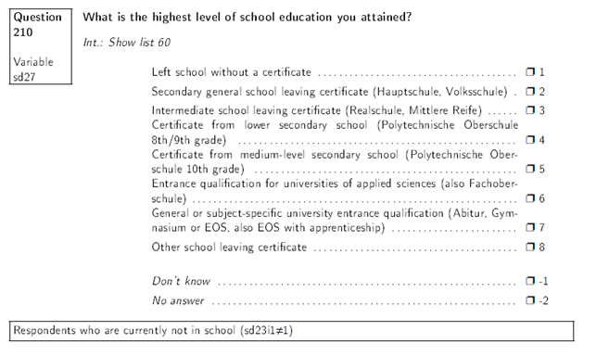**Educational attainment**



Source: Codebook Anchor, Wave 1

<http://www.pairfam.de/fileadmin/user_upload/redakteur/publis/Dokumentation/Codebooks/Release5.0/Codebook_Anchor1_en.pdf>

Note: I will only use the information provided by the anchor.

1. 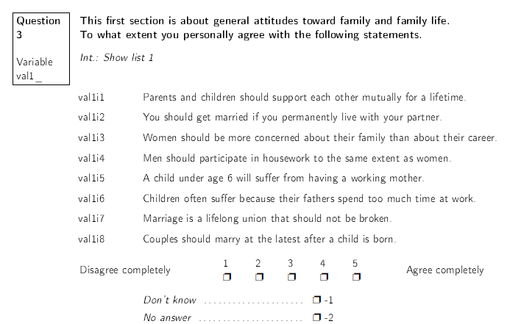**Statements about norms**

Source: Codebook Anchor, Wave 1

<http://www.pairfam.de/fileadmin/user_upload/redakteur/publis/Dokumentation/Codebooks/Release5.0/Codebook_Anchor1_en.pdf>

Note: The statements are exactly the same for anchor and partner. The only difference is the variable’s name.

1. 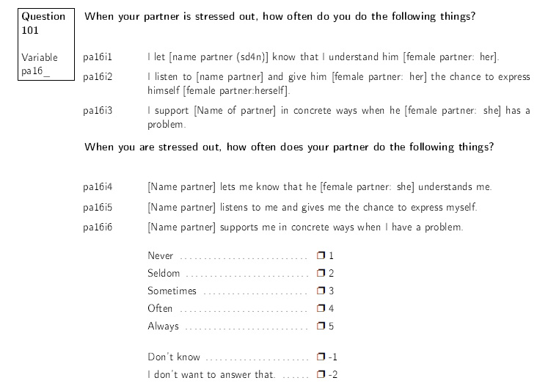**Indicators relationship quality**

Source: Codebook Anchor, Wave 1

<http://www.pairfam.de/fileadmin/user_upload/redakteur/publis/Dokumentation/Codebooks/Release5.0/Codebook_Anchor1_en.pdf>

Note: The statements are exactly the same for anchor and partner. The only difference is the variable’s name.

1. **Relationship stability**
2. 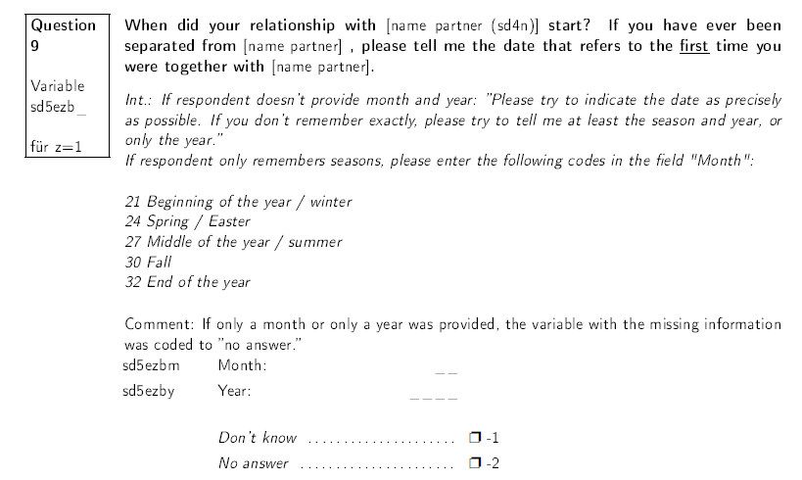**objective**

Source: Codebook Anchor, Wave 1

<http://www.pairfam.de/fileadmin/user_upload/redakteur/publis/Dokumentation/Codebooks/Release5.0/Codebook_Anchor1_en.pdf>

Note: The statements are exactly the same for anchor and partner. The only difference is the variable’s name.

1. **subjective**

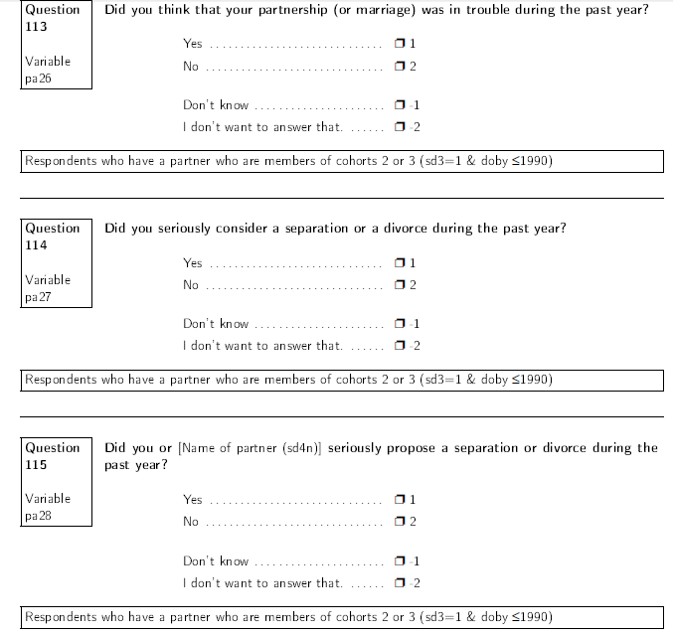

Source: Codebook Anchor, Wave 1

<http://www.pairfam.de/fileadmin/user_upload/redakteur/publis/Dokumentation/Codebooks/Release5.0/Codebook_Anchor1_en.pdf>

Note: The statements are exactly the same for anchor and partner. The only difference is the variable’s name.

1. **Control variables**

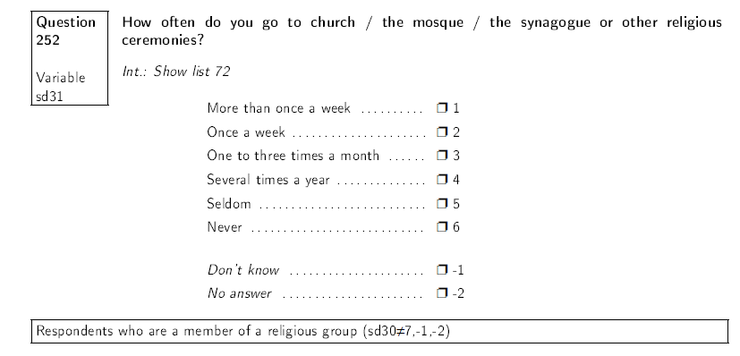

Source: Codebook Anchor, Wave 1

<http://www.pairfam.de/fileadmin/user_upload/redakteur/publis/Dokumentation/Codebooks/Release5.0/Codebook_Anchor1_en.pdf>

Note: The statements are exactly the same for anchor and partner. The only difference is the variable’s name.

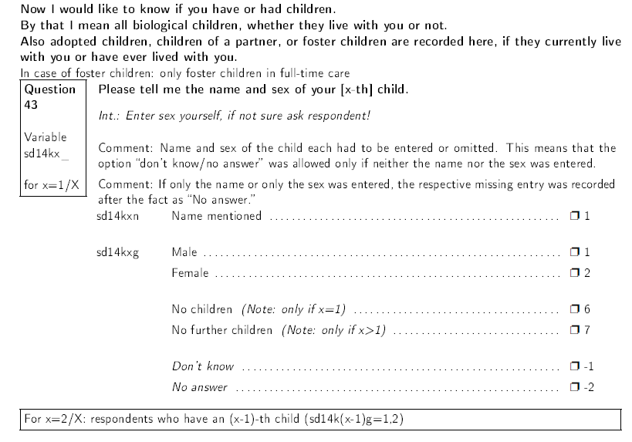

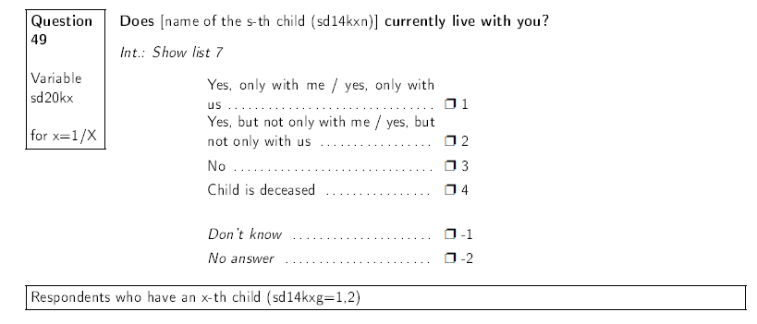

Source: Codebook Anchor, Wave 1

<http://www.pairfam.de/fileadmin/user_upload/redakteur/publis/Dokumentation/Codebooks/Release5.0/Codebook_Anchor1_en.pdf>

Note: I am only going to use the information provided by the anchor.

1. Although he refers to studies on marriages, I do not see a compelling reason why the correlation between relationship quality and stability should be different for cohabiting, not married couples.
2. The data set is already in my possession.
3. Unfortunately, pairfam didn’t offer the option *University degree* which might be a problem. There is a follow-up question that asks if the anchor or partner, respectively, has completed *some kind of vocational training or earn a university degree*. However, it is not possible to separate vocational training and university degree which is why I will focus on the educational attainment as described above.
4. Please see appendix for a list of these statements.
5. Please see appendix for a complete list of the questions concerning the indicators of relationship quality.
6. Once again, I will take the utmost care to ensure that no persons with missing values are included.
7. Since pairfam only asks for the year in which the relationship began (sd5e1by), I have to create a variable that measures the duration by subtracting the given values from 2008 (the year pairfam started its data collection).
8. I am aware of the disadvantages of this operationalization. Unfortunately, there is no variable that contains information about the subjective degree of religiousness.